Ex.No. 1 | Download, install and explore the features of  NumPy, SciPy, Jupyter, Statsmodels and Pandas packages
Date :

Aim:
To Download,Install and Explore the features of NumPy, Scipy, Jupyter , Statsmodels and Pandas Packages.

Download & Install Anaconda Distribution

Follow the below step-by-step instructions to install Anaconda distribution.

Download Anaconda Distribution

Go to https://anaconda.com/ and select Anaconda Individual Edition to download the latest version of Anaconda. This downloads the .exe file to the windows download folder.
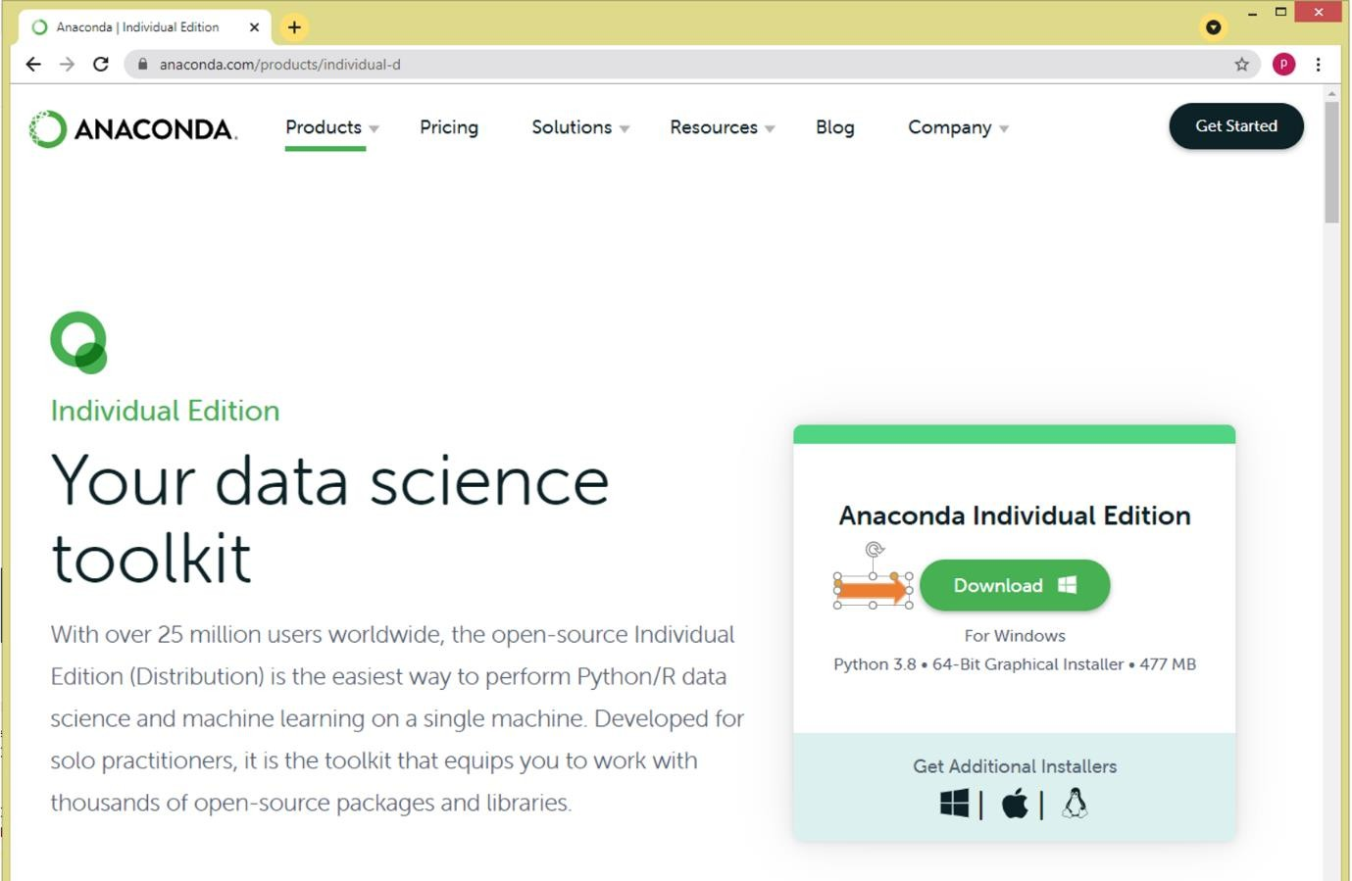

Install Anaconda

By double-clicking the .exe file starts the Anaconda installation. Follow the below screen shot’s and complete the installation

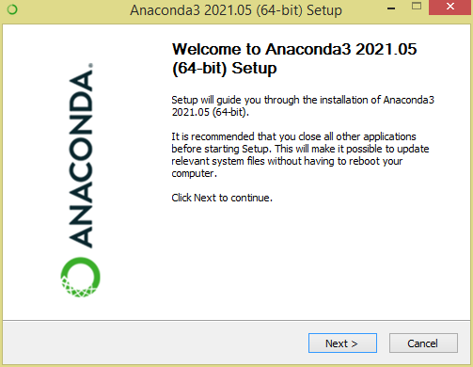

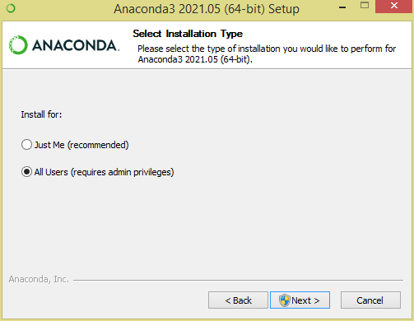
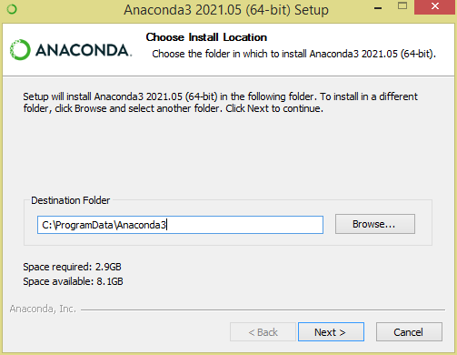

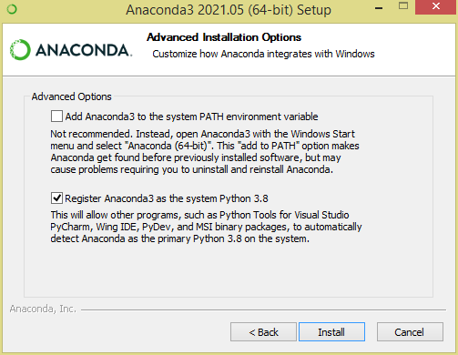
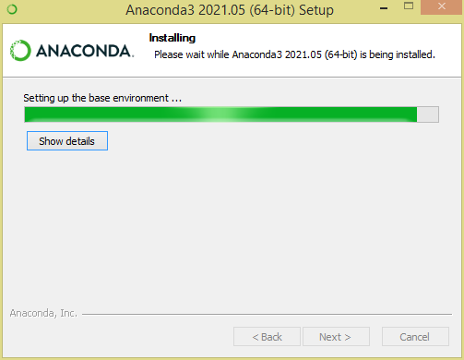

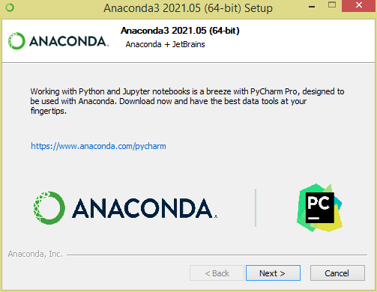
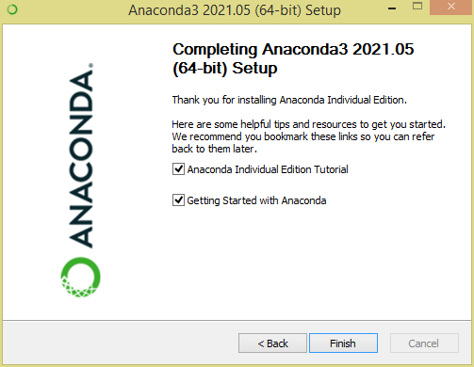

This finishes the installation of Anaconda distribution, now let’s see how to create an environment and install Jupyter Notebook.

Create Anaconda Environment from Navigator

A conda environment is a directory that contains a specific collection of conda packages that you have installed. For example, you may have one environment with NumPy 1.7 and its dependencies, and another environment with NumPy 1.6 for legacy testing.
https://conda.io/docs/using/envs.html
Open Anaconda Navigator

Open Anaconda Navigator from windows start or by searching it. Anaconda Navigator is a UI application where you can control the Anaconda packages, environment e.t.c

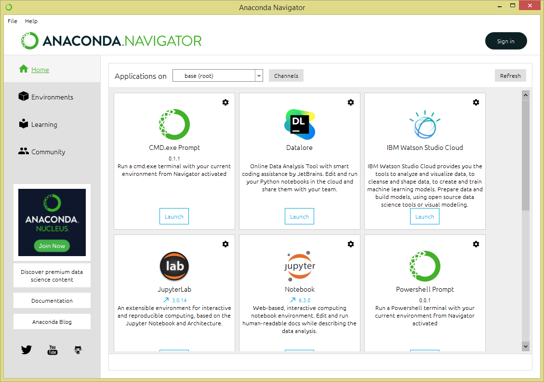
Create an Environment to Run Jupyter Notebook

This is optional but recommended to create an environment before you proceed. This gives complete segregation of different package installs for different projects you would be working on. If you already have an
environment, you can use it too.

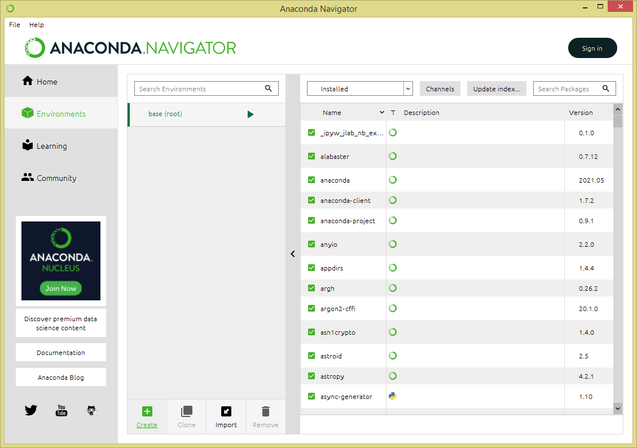

select + Create icon at the bottom of the screen to create an Anaconda environment.
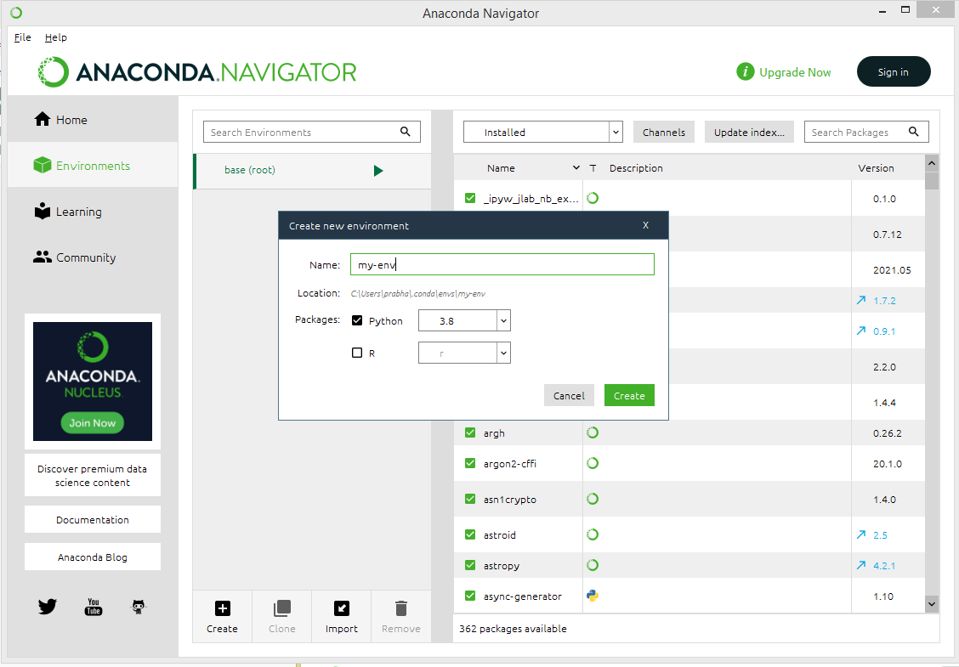

Install and Run Jupyter Notebook

Once you create the anaconda environment, go back to the Home page on Anaconda Navigator and install Jupyter Notebook from an application on the right panel.

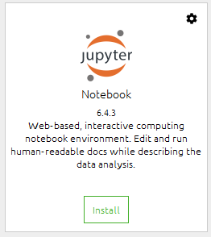

It will take a few seconds to install Jupyter to your environment, once the install completes, you can open Jupyter from the same screen or by accessing Anaconda Navigator -> Environments -> your
environment (mine pandas-tutorial) -> select Open With Jupyter Notebook.
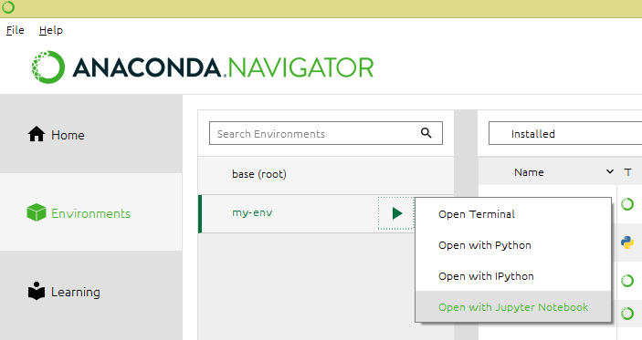
This opens up Jupyter Notebook in the default browser.

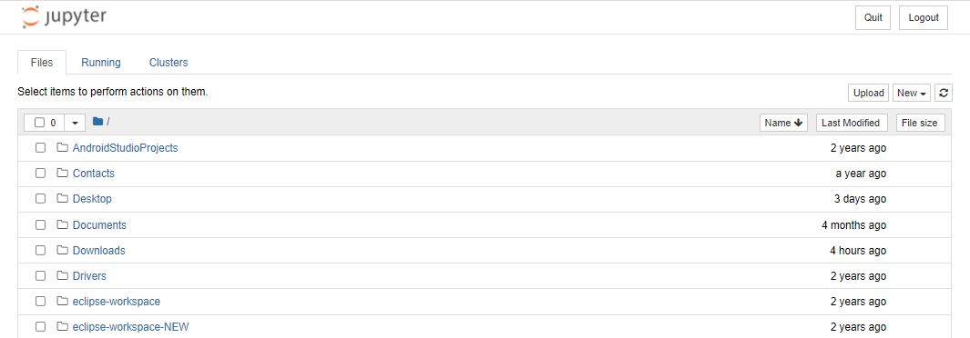

Now select New -> PythonX and enter the below lines and select Run. On Jupyter, each cell is a statement, so you can run each cell independently when there are no dependencies on previous cells.
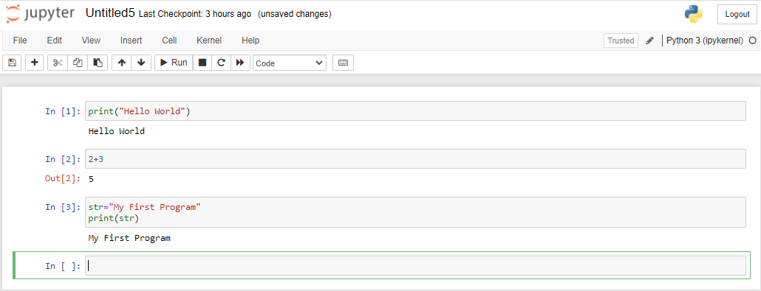
This completes installing Anaconda and running Jupyter Notebook.
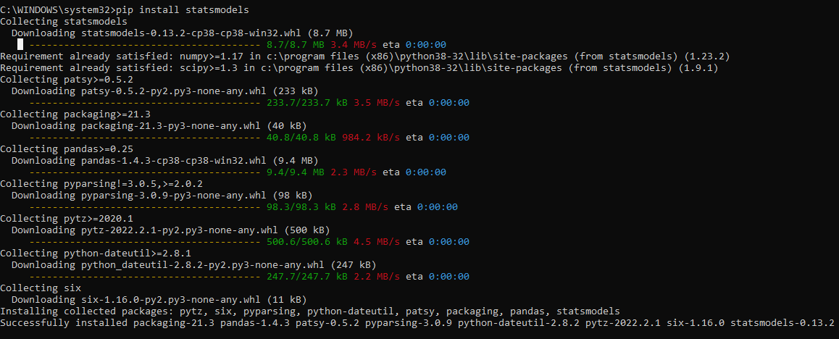

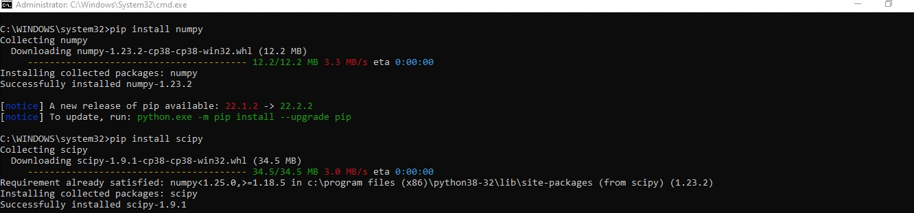
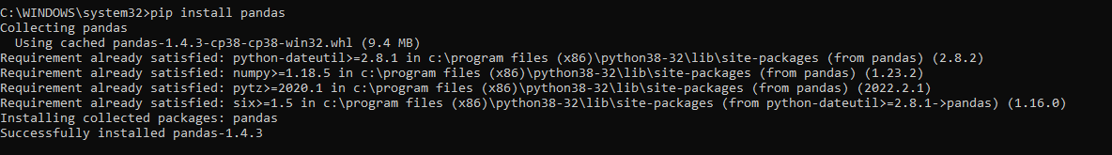
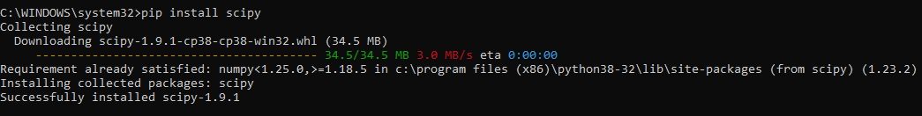

RESULT:
Thus Jupyter Notebook environment has been successfully installed with all the necessary packages using Anaconda distribution.

Ex.No. 2 | Working with Numpy arrays
Date : | Working with Numpy arrays

Aim
To implement array object using Numpy module in Python programming

Algorithm
Step 1: Start the program
Step 2: Import the required packages
Step 3: Read the elements through list/tuple/dictionary
Step 4: Convert List/tuple/dictionary into array using built-in methods Step Step 5: Check the number of dimensions in an array
Step 6: Compute the shape of an array or if it’s required reshape an array
Step 7: Do the required operations like slicing, iterating, searching, concatenating and splitting an array element.
Step 8: Stop the program
Program

import numpy as np

# ------------------ Median of 1D Array ------------------- print("\n--- Median of 1D Array ---") # Create a 1D NumPy array
arr_1d = np.array([1, 3, 5, 7, 9, 11, 13, 15])

# Calculate the median of the array median_1d = np.median(arr_1d) print("1D Array:", arr_1d)
print("Median of 1D array:", median_1d)

# ------------------ Median of 2D Array ------------------- print("\n--- Median of 2D Array ---") # Create a 2D NumPy array
arr_2d = np.array([[10, 20, 30], [40, 50, 60], [70, 80, 90]])

# Calculate the median of the entire array median_2d = np.median(arr_2d) print("2D Array:\n", arr_2d) print("Median of entire 2D array:", median_2d)

# ------------------ Median along Specific Axes ------------------- print("\n--- Median Along Specific Axes ---") # Median along axis 0 (along columns) median_axis_0 = np.median(arr_2d, axis=0)
print("Median along axis 0 (columns):", median_axis_0)

# Median along axis 1 (along rows) median_axis_1 = np.median(arr_2d, axis=1)
print("Median along axis 1 (rows):", median_axis_1)

# ------------------ Median of Randomly Generated Array ------------------- print("\n--- Median of Randomly Generated Array ---") # Generate a random 3x4 array with values between 1 and 100 random_arr = np.random.randint(1, 100, size=(3, 4))
print("Random 3x4 array:\n", random_arr)

# Calculate the median of the random array median_random = np.median(random_arr) print("Median of the random array:", median_random)

# Calculate the median along axis 0 (columns) of the random array median_random_axis_0 = np.median(random_arr, axis=0)
print("Median along axis 0 (columns) of random array:", median_random_axis_0)

# Calculate the median along axis 1 (rows) of the random array median_random_axis_1 = np.median(random_arr, axis=1)
print("Median along axis 1 (rows) of random array:", median_random_axis_1)
Output
Array is of type: <class 'numpy.ndarray'>
No. of dimensions: 2
Shape of array: (2, 3)
Size of array: 6
Array stores elements of type: int64

---------------------------------------------------------------------

[[1 2 3]
[3 4 5]
[4 5 6]]
After slicing
[[3 4 5]
[4 5 6]]

---------------------------------------------------------------------

Our array is:
[[1 2 3]
[3 4 5]
[4 5 6]]
The items in the second column are:
[2 4 5]

The items in the second row are:
[3 4 5]

The items column 1 onwards are:
[[2 3]
[4 5]
[5 6]]

RESULT:
Thus Array object has been explored using Numpy module in Python programming successfully.

Ex.No. 3 | Working with Pandas data frames
Date : | Working with Pandas data frames

Aim:
To work with DataFrame object using Pandas module in Python Programming

Algorithm:
Step 1: Start the program
Step 2: Import the required packages
Step 3: Create a DataFrame using built in method.
Step 4: Load data into a DataFrame object otherwise Load Files(excel/csv) into a DataFrame
Step 5: Display the rows and describe the data set using built in method. Step 6: Display the last 5 rows of the DataFrame.
Step 7: Check the number of maximum returned rows Step 8: Stop the program
Program

import numpy as np
import pandas as pd
data = np.array([['','Col1','Col2'], ['Row1',1,2], ['Row2',3,4]])
print(pd.DataFrame(data=data[1:,1:], index = data[1:,0], columns=data[0,1:]))
my_2darray = np.array([[1, 2, 3], [4, 5, 6]])
print(pd.DataFrame(my_2darray))
my_dict = {1: ['1', '3'], 2: ['1', '2'], 3: ['2', '4']}
print(pd.DataFrame(my_dict))
my_df = pd.DataFrame(data=[4,5,6,7], index=range(0,4), columns=['A'])
print(pd.DataFrame(my_df))
my_series = pd.Series({"United Kingdom":"London", "India":"New Delhi", "United States":"Washington", "Belgium":"Brussels"})
print(pd.DataFrame(my_series))
df = pd.DataFrame(np.array([[1, 2, 3], [4, 5, 6]]))
print(df.shape)
print(len(df.index))
Output

Col1 Col2
Row1 1 2
Row2 3 4
0 1 2
- 1 2 3
- 4 5 6
1 2 3
- 1 1 2
- 3 2 4
A
- 4
- 5
- 6
- 7
0
United Kingdom London
India New Delhi
United States Washington
Belgium Brussels
(2, 3)
2

RESULT:
Thus Data Frame object using Pandas module in Python Programming has been successfully explored

Ex.No. 4 | Reading data from text files, Excel and the web and exploring various commands for doing descriptive analytics on the Iris data set.
Date :

Aim:
To perform descriptive analytics on Iris dataset using Python programming

Algorithm
Step 1: Start the program
Step 2: Import the required packages
Step 3: Load Files(excel/csv/ text) into a DataFrame from Iris data set Step 4: Display the rows and describe the data set using built in methods Step 5: Compare Petal Length and Petal Width
Step 6: Visualize the data set using histogram with distplot, heatmaps box plots methods
Step 7: Check Missing Values, Duplicates and remove outliers Step 8: Stop the program

Program
import pandas as pd
# Reading the CSV file
df = pd.read_csv("Iris.csv") # Printing top 5 rows df.head()

Output:

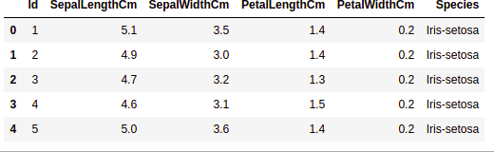

Getting Information about the Dataset
df.shape

Output:
(150, 6)
df.info()

Output
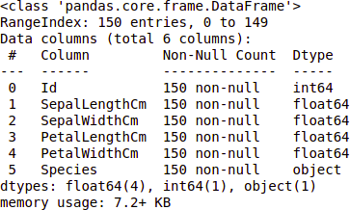

df.describe()

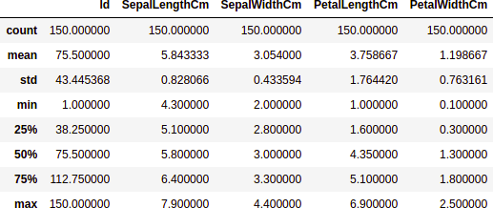

Checking Missing Values
df.isnull().sum()

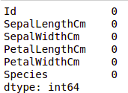

Checking Duplicates

data = df.drop_duplicates(subset ="Species",) data

Output

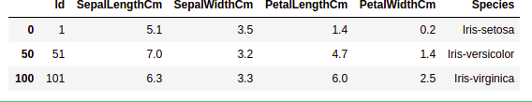

df.value_counts("Species")
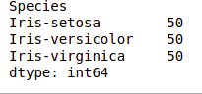

Data Visualization

# importing packages import seaborn as sns
import matplotlib.pyplot as plt sns.countplot(x='Species', data=df, ) plt.show()

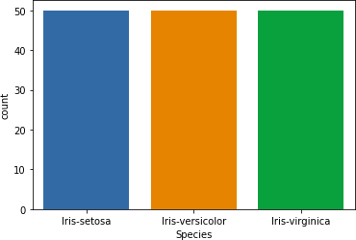

Comparing Sepal Length and Sepal Width
# importing packages import seaborn as sns
import matplotlib.pyplot as plt sns.scatterplot(x='SepalLengthCm', y='SepalWidthCm',
hue='Species', data=df, ) # Placing Legend outside the Figure plt.legend(bbox_to_anchor=(1, 1), loc=2)
plt.show()
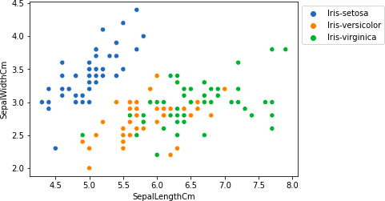

# importing packages
import seaborn as sns
import matplotlib.pyplot as plt sns.pairplot(df.drop(['Id'], axis = 1),
hue='Species', height=2)

Output:
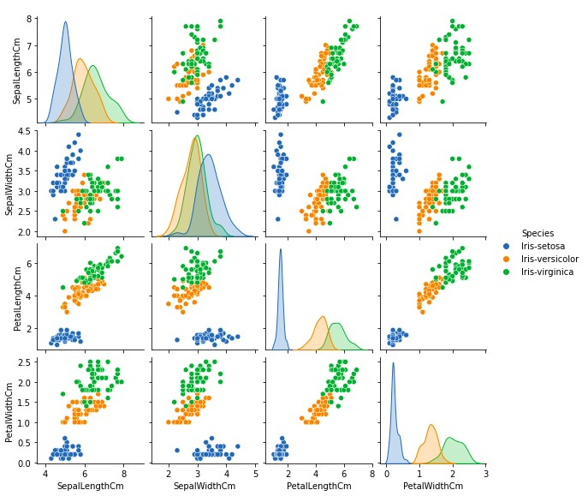

Histograms
Program

# importing packages
import seaborn as sns
import matplotlib.pyplot as plt
fig, axes = plt.subplots(2, 2, figsize=(10,10)) axes[0,0].set_title("Sepal Length") axes[0,0].hist(df['SepalLengthCm'], bins=7) axes[0,1].set_title("Sepal Width") axes[0,1].hist(df['SepalWidthCm'], bins=5) axes[1,0].set_title("Petal Length") axes[1,0].hist(df['PetalLengthCm'], bins=6) axes[1,1].set_title("Petal Width") axes[1,1].hist(df['PetalWidthCm'], bins=6)

Output:

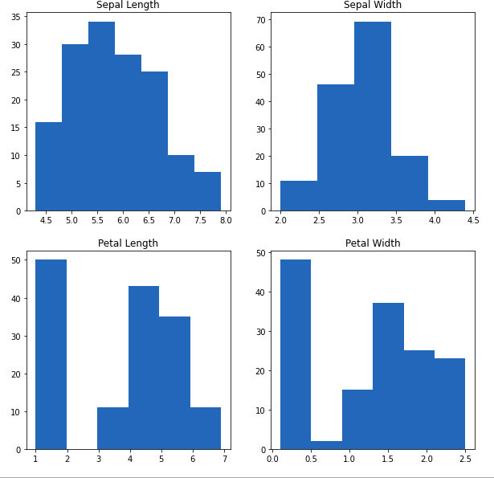

Histograms with Distplot Plot
Program

# importing packages
import seaborn as sns
import matplotlib.pyplot as plt

plot = sns.FacetGrid(df, hue="Species") plot.map(sns.distplot, "SepalLengthCm").add_legend() plot = sns.FacetGrid(df, hue="Species") plot.map(sns.distplot, "SepalWidthCm").add_legend() plot = sns.FacetGrid(df, hue="Species") plot.map(sns.distplot, "PetalLengthCm").add_legend() plot = sns.FacetGrid(df, hue="Species") plot.map(sns.distplot, "PetalWidthCm").add_legend() plt.show()

Output:

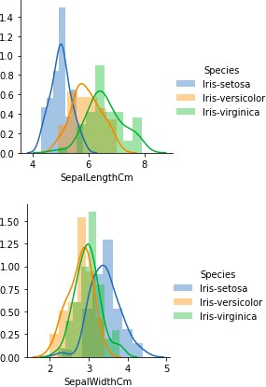

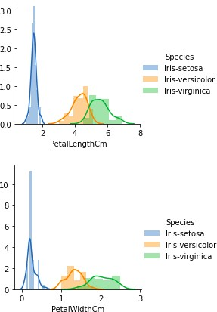

Handling Correlation

data.corr(method='pearson')

Output:
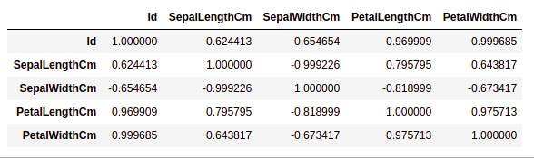

Heatmaps

Program

# importing packages
import seaborn as sns
import matplotlib.pyplot as plt sns.heatmap(df.corr(method='pearson').drop(
['Id'], axis=1).drop(['Id'], axis=0),
annot = True); plt.show()

Output:
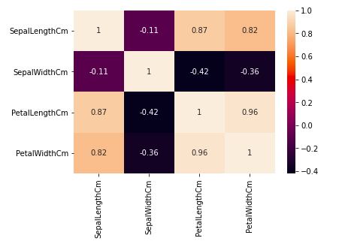

Box Plots
Program

# importing packages
import seaborn as sns
import matplotlib.pyplot as plt
def graph(y):
sns.boxplot(x="Species", y=y, data=df) plt.figure(figsize=(10,10))
# Adding the subplot at the specified # grid position
plt.subplot(221) graph('SepalLengthCm') plt.subplot(222) graph('SepalWidthCm') plt.subplot(223) graph('PetalLengthCm') plt.subplot(224) graph('PetalWidthCm') plt.show()

Output:

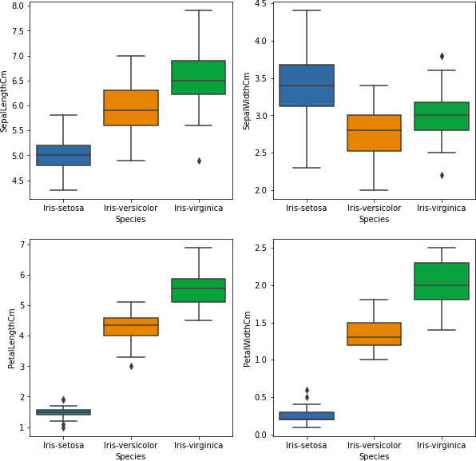
Program

# importing packages
import seaborn as sns
import matplotlib.pyplot as plt # Load the dataset
df = pd.read_csv('Iris.csv') sns.boxplot(x='SepalWidthCm', data=df)

Output:

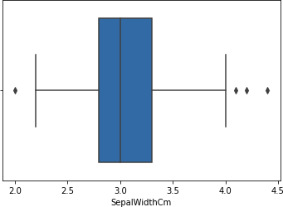

Removing Outliers Program
# Importing
import sklearn
from sklearn.datasets import load_boston import pandas as pd
import seaborn as sns # Load the dataset
df = pd.read_csv('Iris.csv') # IQR
Q1 = np.percentile(df['SepalWidthCm'], 25,
interpolation = 'midpoint')
Q3 = np.percentile(df['SepalWidthCm'], 75,
interpolation = 'midpoint')
IQR = Q3 - Q1
print("Old Shape: ", df.shape) # Upper bound
upper = np.where(df['SepalWidthCm'] >= (Q3+1.5*IQR)) # Lower bound
lower = np.where(df['SepalWidthCm'] <= (Q1-1.5*IQR))

# Removing the Outliers df.drop(upper[0], inplace = True) df.drop(lower[0], inplace = True) print("New Shape: ", df.shape) sns.boxplot(x='SepalWidthCm', data=df)

Output:
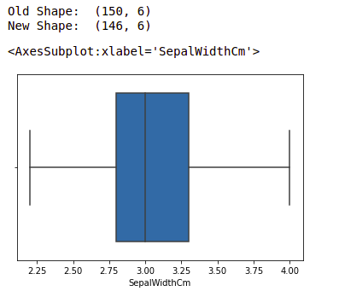

RESULT:
Thus Iris dataset has been explored and descriptively analysed using Python programming.

Ex.No. 5 | Use the diabetes data set from UCI and Pima Indians Diabetes data set for performing the following:
Date :

Aim:
To perform various exploratory data analysis on Pima Indians Diabetes dataset using Python Programming

Univariate analysis: Frequency, Mean, Median, Mode, Variance, Standard Deviation, Skewness and Kurtosis.
- Bivariate analysis: Linear and logistic regression modeling

Multiple Regression analysis
- Also compare the results of the above analysis for the two data sets. Algorithm
Step 1: Start the program
Step 2: Import the required packages
Step 3: Load Files (excel/csv/ text) into a Data Frame from UCI and Pima Indians Diabetes data set
Step 4: Display the rows and describe the data set using built in methods
Step 5: Compute Frequency, Mean, Median, Mode, Variance, Standard Deviation, Skewness and Kurtosis
Step 6: Visualize the data set using histogram with distplot, heatmaps box plots methods
Step 7: Check Missing Values, Duplicates and remove outliers using built in method Step 8: Stop the program

Program
import pandas as pd import seaborn as sns
import matplotlib.pyplot as plt
%matplotlib inline
from sklearn.linear_model import LogisticRegression from sklearn.externals import joblib
df = pd.read_csv('C:/Users/praveen/Downloads/diabetes.csv')
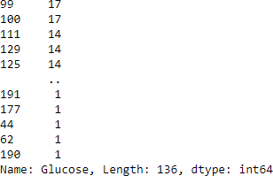
count = df['Glucose'].value_counts() display(count)
df.head()
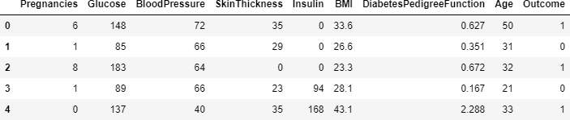
df.describe()
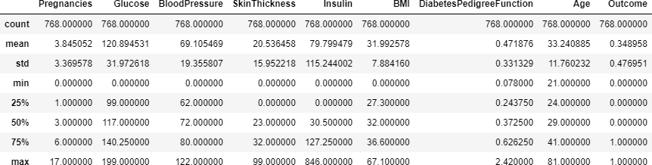

df.mean()
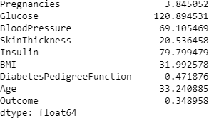
df.mode()

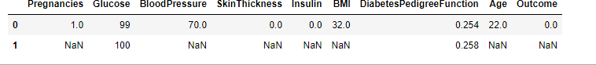

df.var()
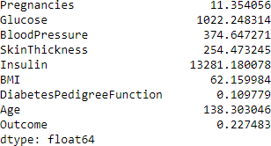

df.std()
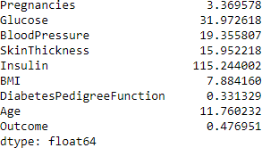

df.skew()
Pregnancies 0.901674 Glucose 0.173754 BloodPressure -1.843608 SkinThickness 0.109372 Insulin 2.272251 BMI -0.428982
DiabetesPedigreeFunction 1.919911 Age 1.129597
Outcome 0.635017 dtype: float64

df.kurtosis()
Pregnancies | 0.159220
Glucose | 0.640780
BloodPressure | 5.180157
SkinThickness | -0.520072

3.290443
BMI
7.214260
Insulin
DiabetesPedigreeFunction 5.594954
Age 0.643159
Outcome -1.600930 dtype: float64

corr = df.corr() sns.heatmap(corr,
xticklabels=corr.columns,
yticklabels=corr.columns)
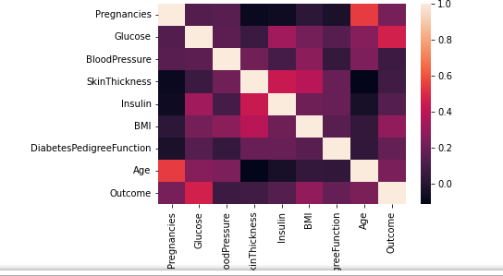

sns.countplot('Outcome', data=df) plt.show()

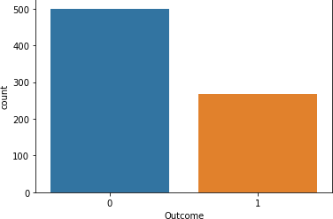

# Computing the %age of diabetic and non-diabetic in the sample Out0=len([df.Outcome==1])
Out1=len([df.Outcome==0]) Total=Out0+Out1
PC_of_1 = Out1*100/Total
PC_of_0 = Out0*100/Total PC_of_1, PC_of_0
(50.0, 50.0)

plt.figure(dpi = 120,figsize= (5,4))
mask = np.triu(np.ones_like(df.corr(),dtype = bool))
sns.heatmap(df.corr(),mask = mask, fmt = ".2f",annot=True,lw=1,cmap = 'plasma') plt.yticks(rotation = 0)
plt.xticks(rotation = 90) plt.title('Correlation Heatmap') plt.show()

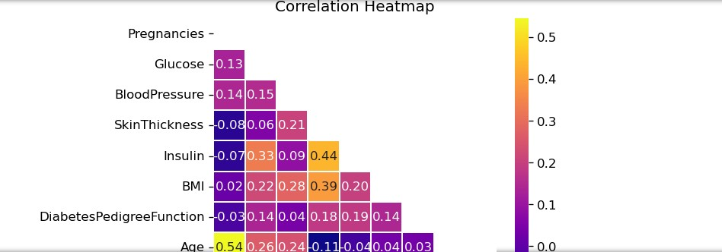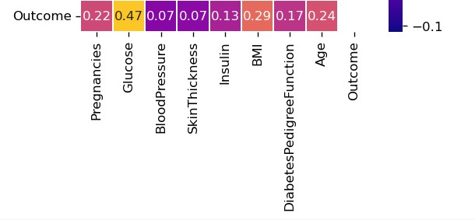

RESULT:
Thus various exploratory data analysis has been performed on Pima Indians Diabetes dataset using Python Programming successfully.

Ex.No. 6 | Apply and explore various plotting functions on UCI data sets.
Date :

Density and contour plots
  - Correlation and scatter plots

Histograms
  - Three dimensional plotting Aim:
To apply various plotting functions on UCI data set using Python Programming

Algorithm
Step 1: Start the program
Step 2: Import the required packages
Step 3: Load Files (excel/csv/ text) into a Data Frame from UCI data set
Step 4: Describe the data set using built in method
Step 5: Compute Frequency, Mean, Median, Mode, Variance, Standard Deviation,
Step 6: Visualize the data set using Explore various plotting functions on UCI data sets for the following
    - Normal curves
    - Density and contour plots
    - Correlation and scatter plots
    - Histograms
    - Three-dimensional plotting
Step 7: Analyze the sample data and do the required operations
Step 8: Stop the program

Normal curves Program
import pandas as pd
import matplotlib.pyplot as plt import numpy as np
df=pd.read_csv("C:/Users/praveen/Downloads/dataset_diabetes/diabetic_data.cs v")

df.head()
mean =df['time_in_hospital'].mean() std =df['time_in_hospital'].std() x_axis = np.arange(1, 10, 0.01)
plt.plot(x_axis, norm.pdf(x_axis, mean, std)) plt.show()

Output
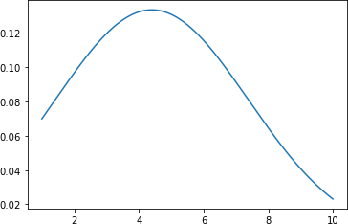

- Density and contour plots Program
df.time_in_hospital.plot.density(color='green') plt.title('Density plot for time_in_hospital') plt.show()

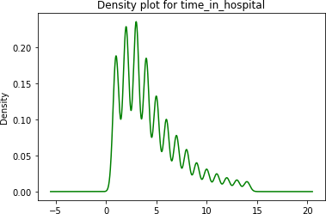

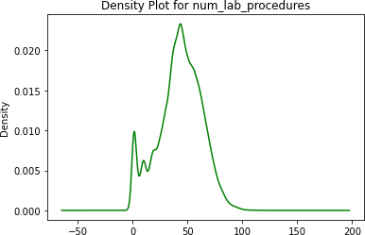
df.num_lab_procedures.plot.density(color='green') plt.title('Density Plot for num_lab_procedures') plt.show()

df.num_medications.plot.density(color='green') plt.title('Density Plot for num_medications') plt.show()

Output
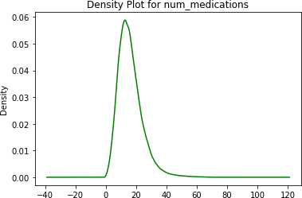

Program
# for 'tip' attribute # using plot.kde()
df.number_emergency.plot.kde(color='green') plt.title('KDE-Density plot for number_emergency') plt.show()

Output
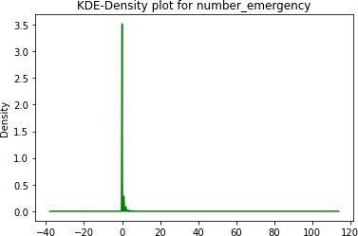

Program
def func(x, y):
return np.sin(x) ** 2 + np.cos(y) **2 # generate 50 values b/w 0 a5
mean =df['time_in_hospital'].mean() std =df['time_in_hospital'].std()
x = np.linspace(0, mean) y = np.linspace(0, std)
# Generate combination of grids X, Y = np.meshgrid(x, y)
Z = func(X, Y)
# Draw rectangular contour plot plt.contour(X, Y, Z, cmap='gist_rainbow_r');

Output
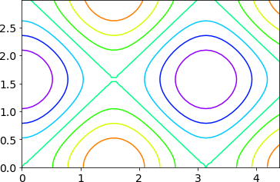

- Correlation and scatter plots Program mp.figure(figsize=(20,10))
dataplot = sb.heatmap(data.corr(), cmap="YlGnBu", annot=True)

Output
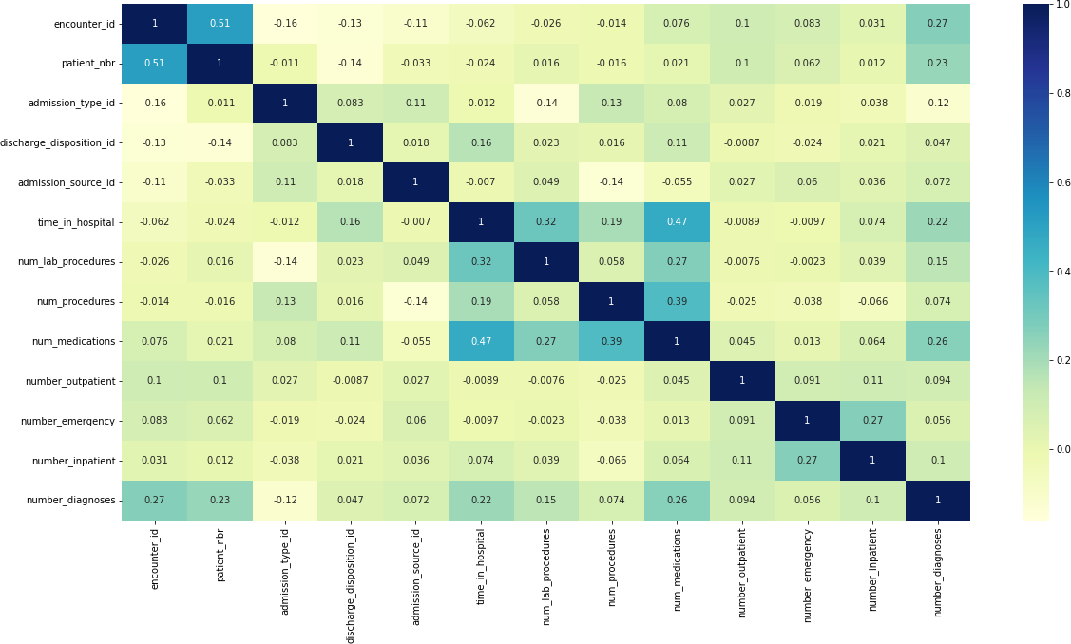

- Histograms Program
df.hist(figsize=(12,12),layout=(5,3))

Output
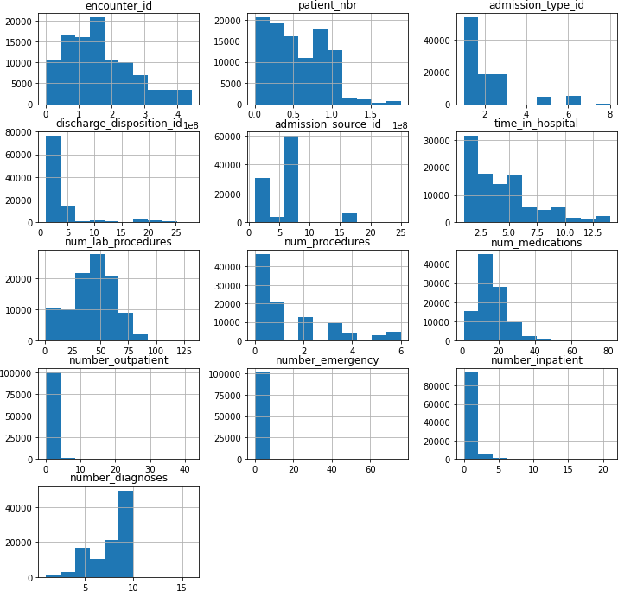

# plotting histogram for carat using distplot() sb.distplot(a=df.num_lab_procedures, kde=False) # visualizing plot using matplotlib.pyplot library plt.show()

Output
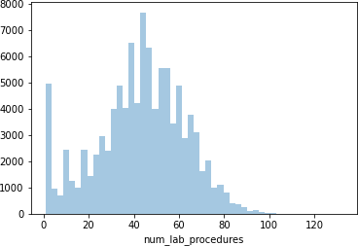

- Three dimensional plotting Program
fig = plt.figure()
ax = plt.axes(projection = '3d') x = df['number_emergency'] x = pd.Series(x, name= '')
y = df['number_inpatient'] y = pd.Series(x, name= '')
z = df['number_outpatient'] z = pd.Series(x, name= '') ax.plot3D(x, y, z, 'green')
ax.set_title('3D line plot diabetes dataset') plt.show()

Output
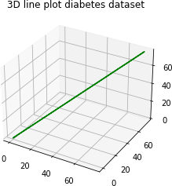

RESULT:
Thus apply various plotting functions on UCI data set using Python Programming

Ex.No. 7 | Visualizing Geographic Data with Basemap
Date : | Visualizing Geographic Data with Basemap

Aim:
To visualize Geographic Data using BaseMap module in Python Programming

Algorithm:
Step 1: Start the program
Step 2: Import the required packages
Step 3: Visualize Geographic Data with Basemap
Step 4: Display the Base map using built in method like basemap along with latitude and longitude parameters
Step 5: Display the Coastal lines meters and Country boundaries using built in methods
Step 6: Fill the Coastal lines meters and Country boundaries with suitable colours
Step 7: Create a global map with a Cylindrical Equidistant Projection, Orthographic
Projection, Robinson Projection
Step 8: Stop the program
Create a global map with a Ortho Projection

Program
%matplotlib inline import numpy as np
import matplotlib.pyplot as plt
from mpl_toolkits.basemap import Basemap plt.figure(figsize=(8, 8))
m = Basemap(projection='ortho', resolution=None, lat_0=50, lon_0=-100) m.bluemarble(scale=0.5);

Output
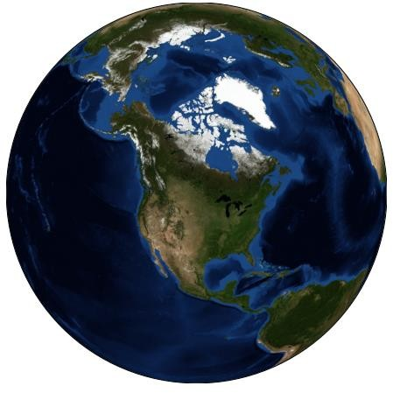

Program
fig = plt.figure(figsize=(8, 8))
m = Basemap(projection='lcc', resolution=None,
width=8E6, height=8E6,
lat_0=45, lon_0=-100,) m.etopo(scale=0.5, alpha=0.5)
# Map (long, lat) to (x, y) for plotting x, y = m(-122.3, 47.6)
plt.plot(x, y, 'ok', markersize=5) plt.text(x, y, ' INDIA', fontsize=12);

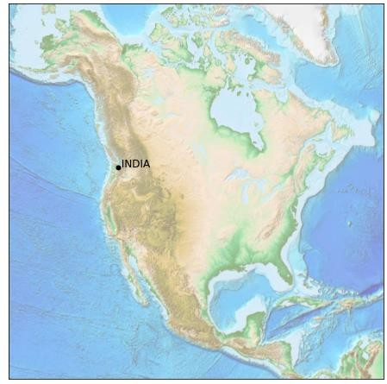
Output

-

Create a global map with a Coastlines Program
fig = plt.figure(figsize = (12,12)) m = Basemap() m.drawcoastlines() plt.title("Coastlines", fontsize=20) plt.show()

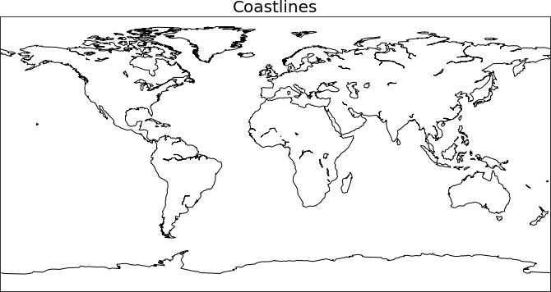

Program
fig = plt.figure(figsize = (12,12)) m = Basemap()
m.drawcoastlines(linewidth=1.0, linestyle='dashed', color='red') plt.title("Coastlines", fontsize=20)
plt.show()
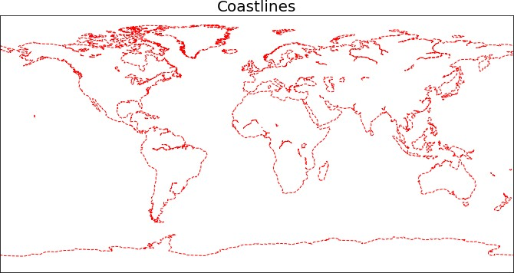

Create a global map with a Country boundaries Program
fig = plt.figure(figsize = (12,12)) m = Basemap()
m.drawcoastlines(linewidth=1.0, linestyle='solid', color='black') m.drawcountries()
plt.title("Country boundaries", fontsize=20) x, y = m(-122.3, 47.6)
plt.plot(x, y, 'ok', markersize=5) plt.text(x, y, ' INDIA', fontsize=12); plt.show()

Output
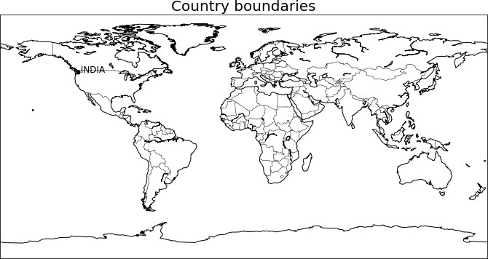

Create a global map with a Mercator Projection Program
fig = plt.figure(figsize = (10,8))
m = Basemap(projection='merc',llcrnrlat=-80,urcrnrlat=80,llcrnrlon=- 180,urcrnrlon=180)
m.drawcoastlines() m.fillcontinents(color='tan',lake_color='lightblue')

m.drawcountries(linewidth=1, linestyle='solid', color='k' ) m.drawmapboundary(fill_color='lightblue') plt.title("Mercator Projection", fontsize=20)

Output
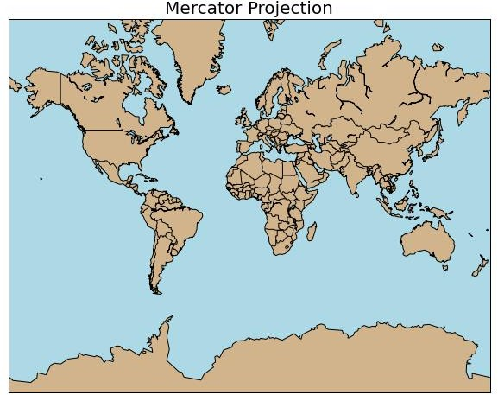

Create a global map with a Cylindrical Equidistant Projection Program
fig = plt.figure(figsize = (10,8))
m = Basemap(projection='cyl',llcrnrlat=-80,urcrnrlat=80,llcrnrlon=-180,urcrnrlon=180) m.drawcoastlines()
m.fillcontinents(color='tan',lake_color='lightblue') m.drawcountries(linewidth=1, linestyle='solid', color='k' ) m.drawmapboundary(fill_color='lightblue')
plt.title(" Cylindrical Equidistant Projection", fontsize=20)

Output
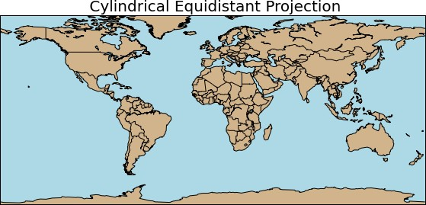

Create a global map with Orthographic Projection Program
fig = plt.figure(figsize = (10,8))
m = Basemap(projection='ortho', lon_0 = 25, lat_0 = 10) m.drawcoastlines() m.fillcontinents(color='tan',lake_color='lightblue') m.drawcountries(linewidth=1, linestyle='solid', color='k' ) m.drawmapboundary(fill_color='lightblue') plt.title("Orthographic Projection", fontsize=18)

Output

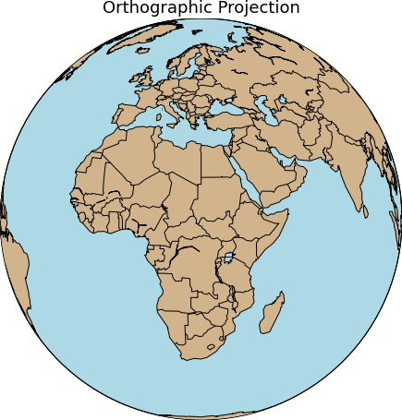

Create a global map with a Robinson Projection Program
fig = plt.figure(figsize = (10,8))
m = Basemap(projection='robin',llcrnrlat=-80,urcrnrlat=80,llcrnrlon=-180,urcrnrlon=180, lon_0 = 0, lat_0 = 0)
m.drawcoastlines() m.fillcontinents(color='tan',lake_color='lightblue') m.drawcountries(linewidth=1, linestyle='solid', color='k' ) m.drawmapboundary(fill_color='lightblue')
plt.title(" Robinson Projection", fontsize=20)

Output
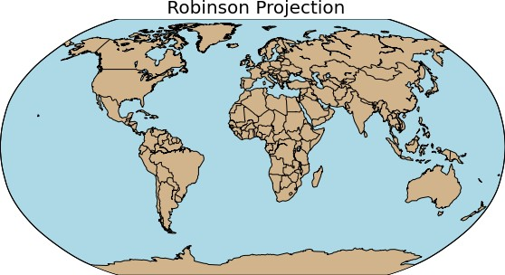

RESULT
Thus Geographic Data has been visualized using Base Map module in Python Programming successfully.

VIVA VOICE

- Benefits of Data Preparations
- What is bias and list its types?
- Write short notes on Discrete and continuous variable
- Define standard normal curve with equation and graph.
- List out the types of non linear relationship.
- Difference between Linear and multiple regressions.
- What is .loc( ), .iloc( ), .ix( ) ?
- Differentiate append() and concat() in pandas.
- Write Short notes on KDE
- Define seaborn plots.
- Identify the steps of data science process
- What is data cleaning?
- Differentiate Histogram and bar graph
- What is Z-Score?
- Define Causation.
- Compare Correlation and Regression.
- Where is NumPy used?
- “List is mutable”- Justify with example
- What is density plot?
- Write the significance of Data Visualization.

